LAB Q A

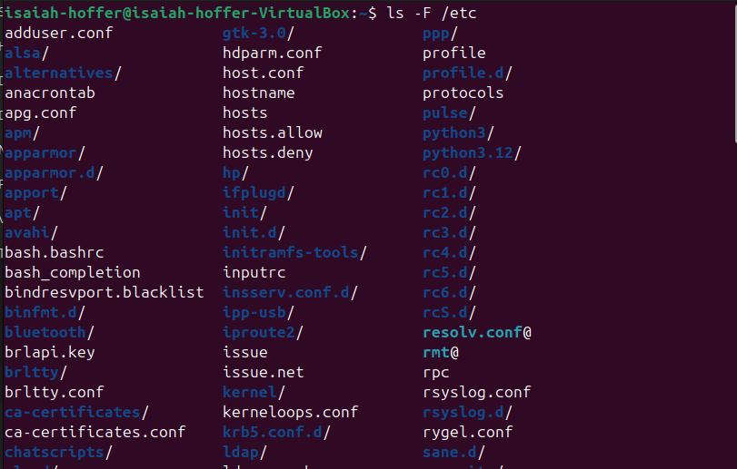

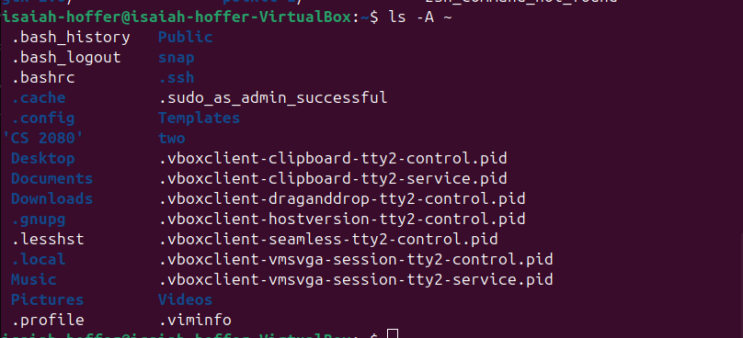

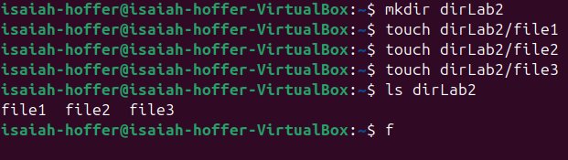

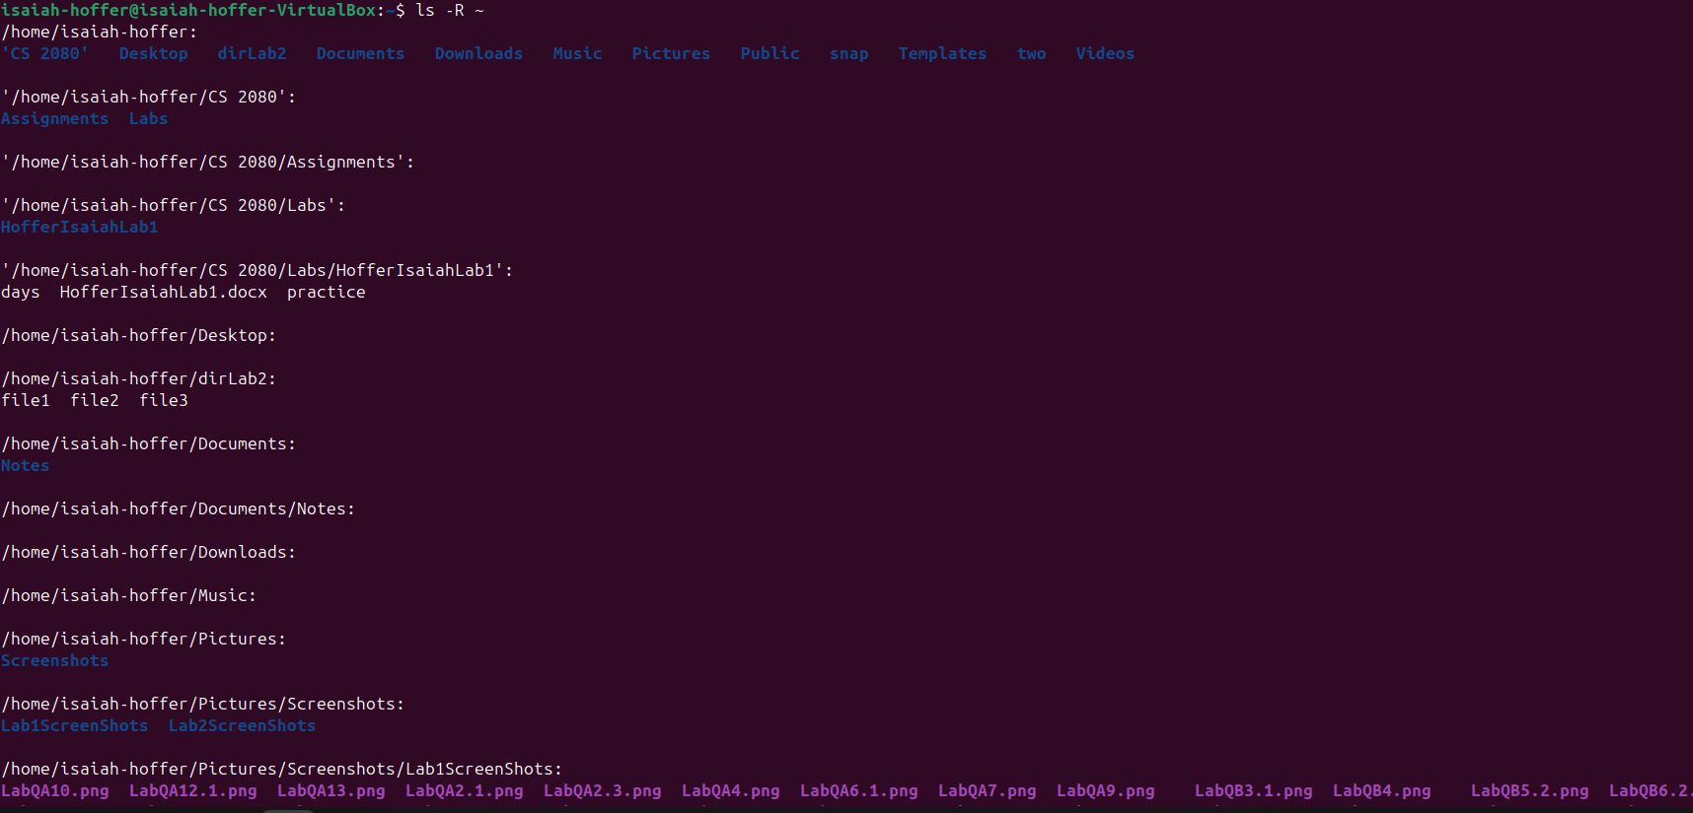

LAB Q C.1 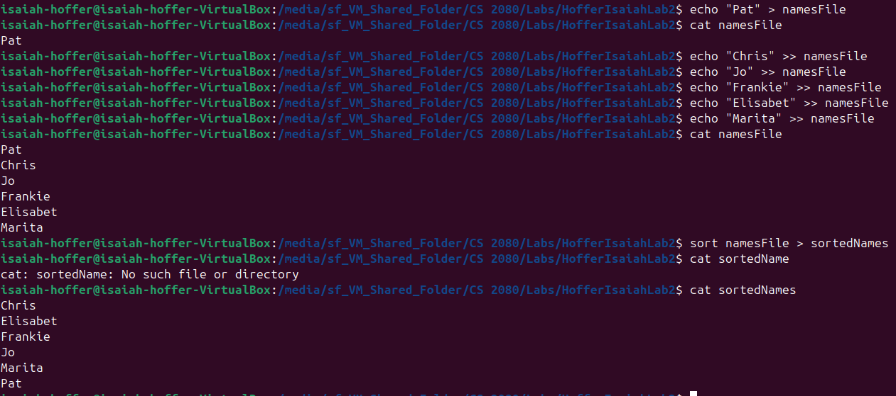

LAB Q C.2

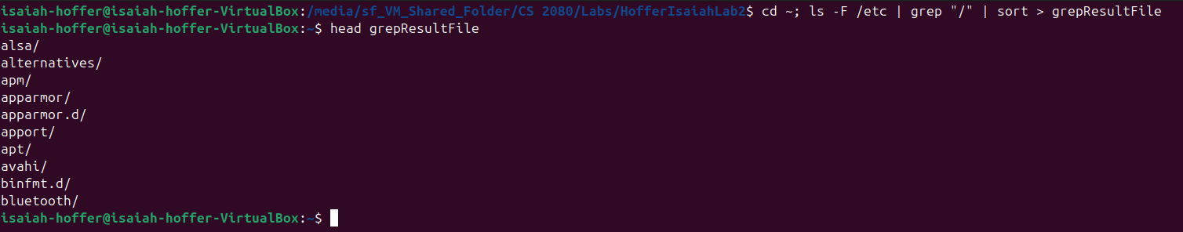

LAB Q E.1

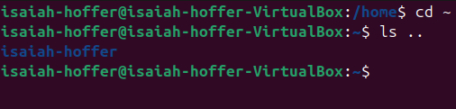

LAB Q E.2



LAB Q E.3

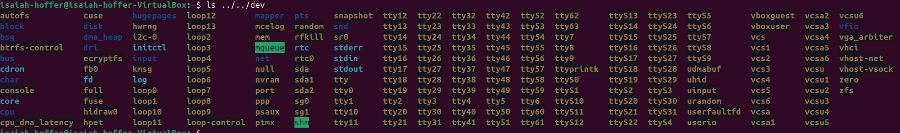

LAB Q E.4



LAB Q F.1

LAB Q F.2

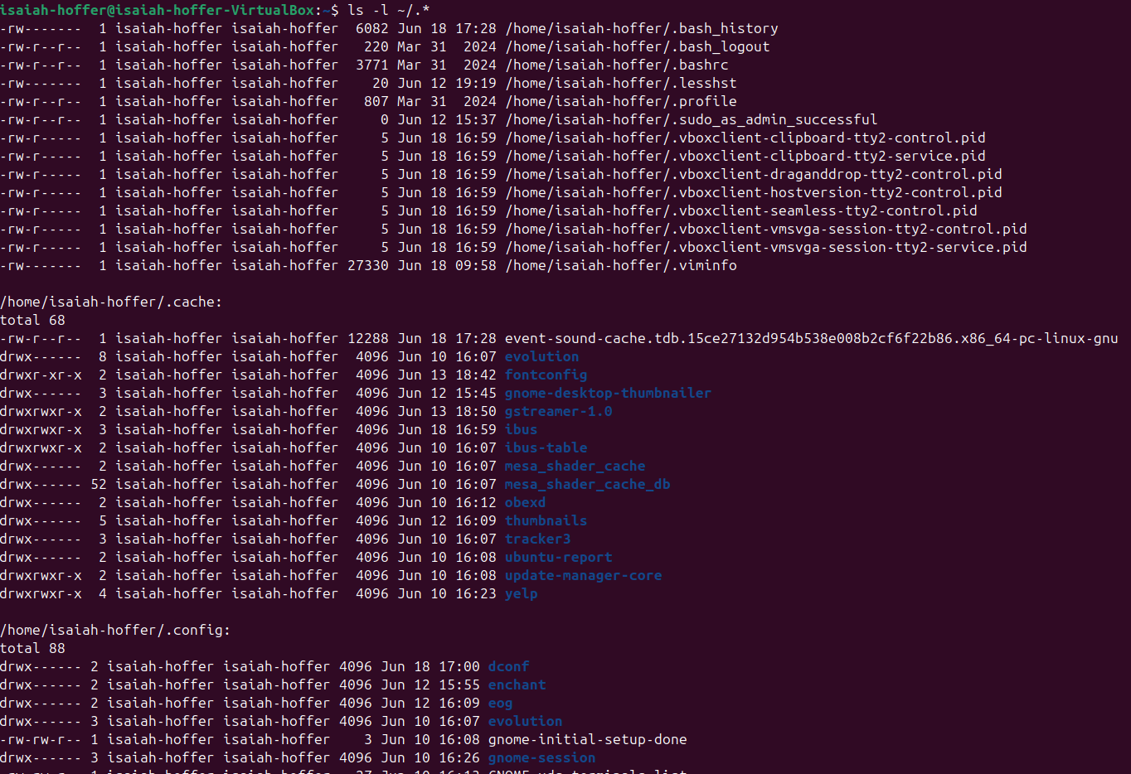

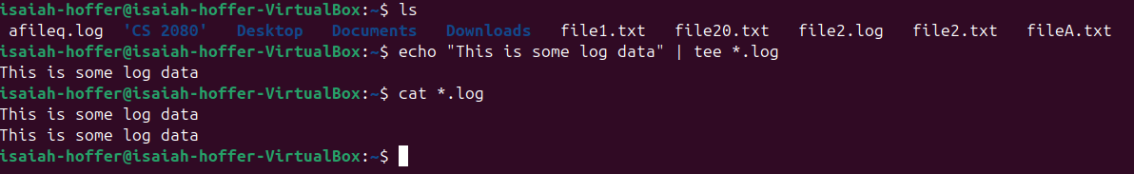

LAB Q F.3

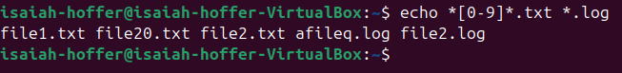

LAB Q F.4

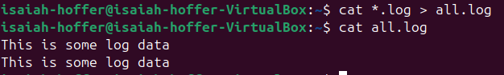

LAB Q F.5

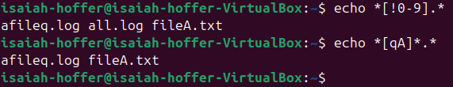

LAB Q F.6

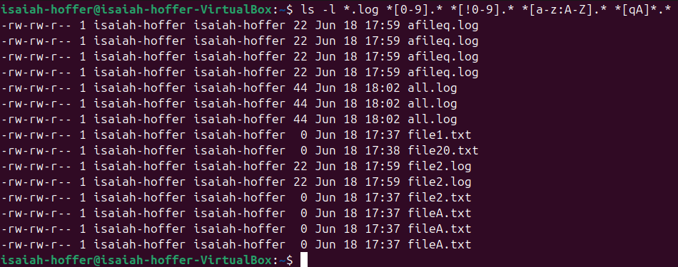

LAB Q G

A.

B. Section 10

C.

D.

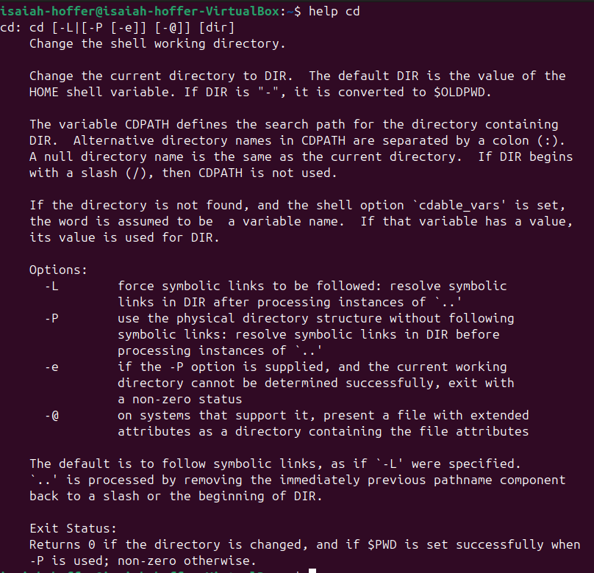

LAB Q H.1

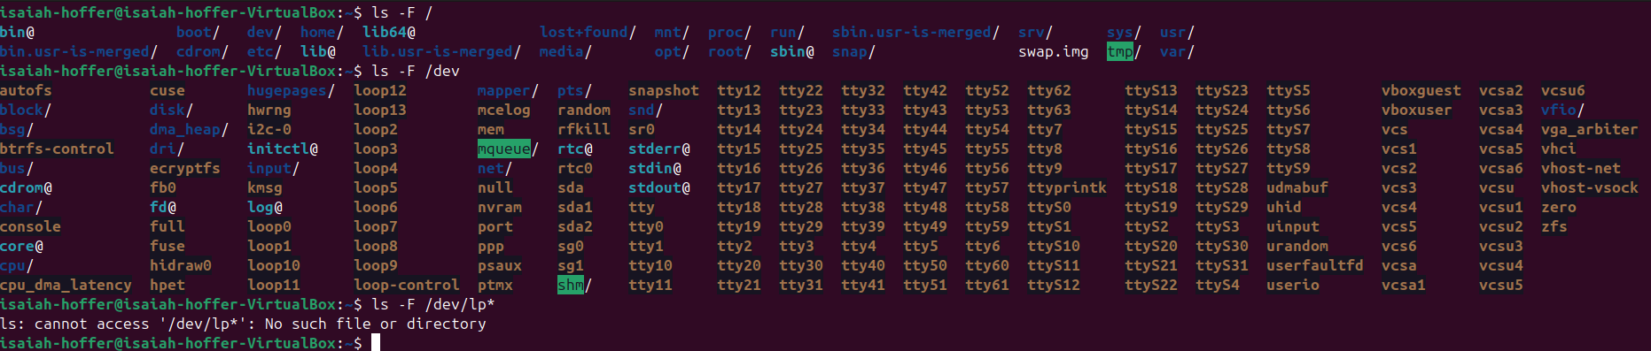

B. Line Printers: 0

Storage Disks: 1

Partitions: 2

LAB Q H.2

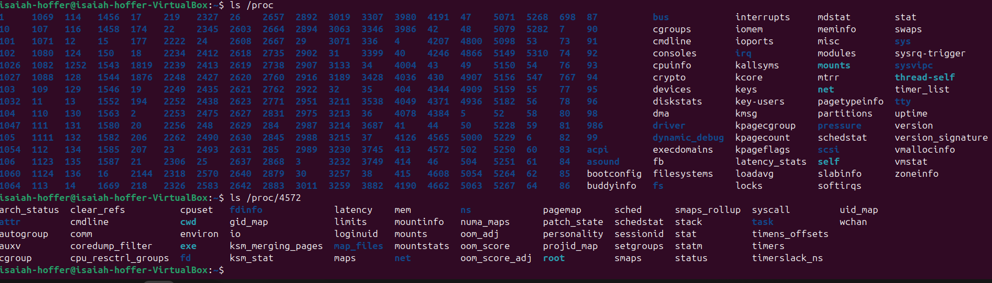

LAB Q I.1

The hardLink and originalNotLink inode number are the same, so is the hard link count

LAB Q I.2

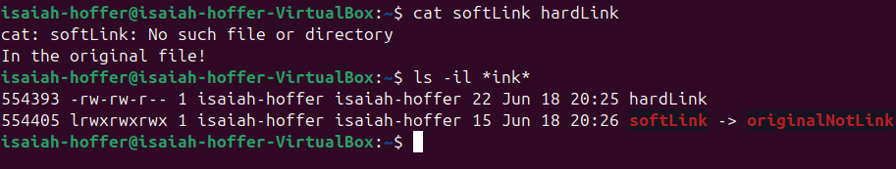

The inode numbers are the same, but the hardLink count went down by one.

LAB Q J.3

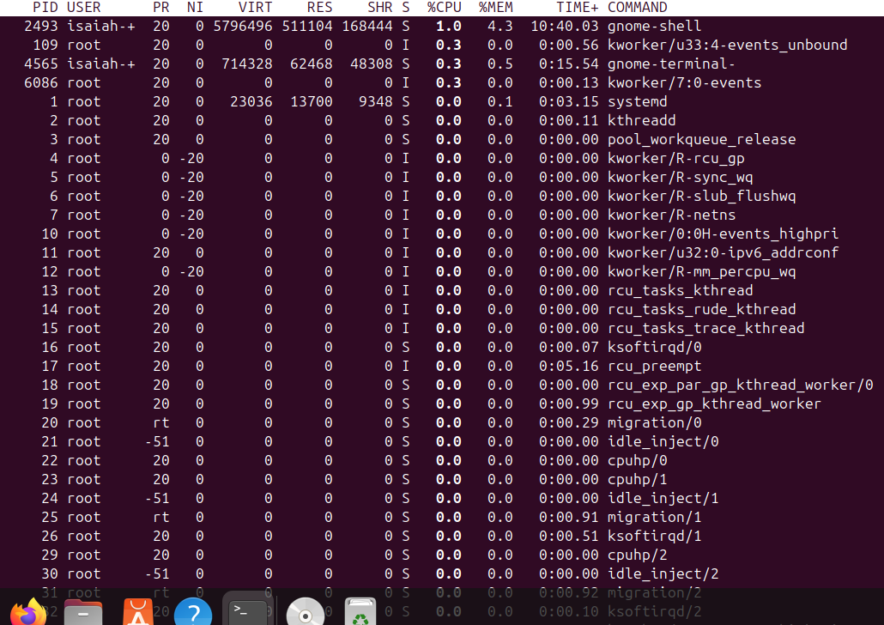

LAB Q K.2

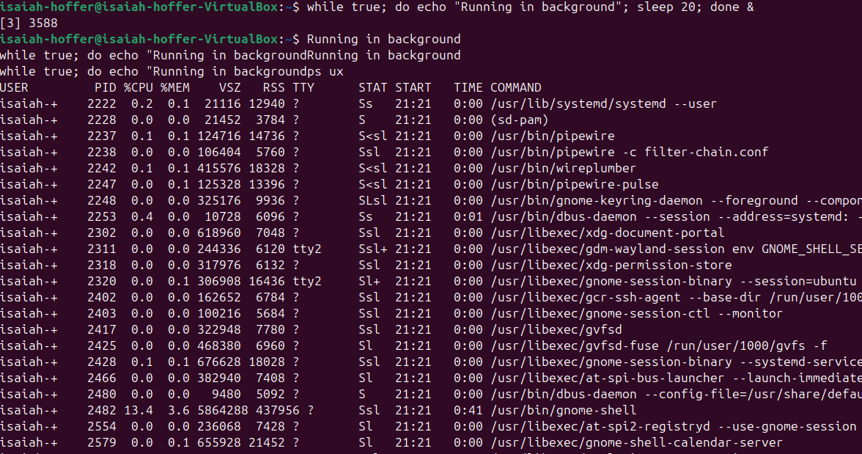

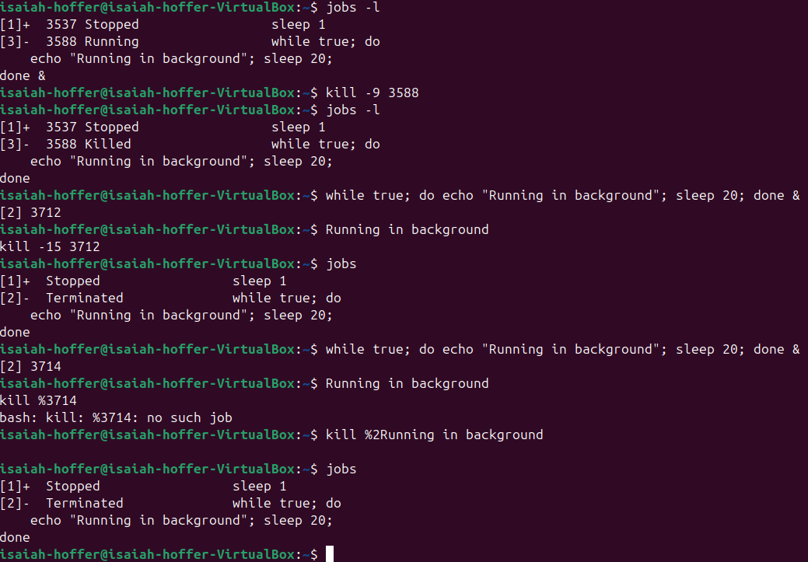

LAB Q K.3